Fraud Email detection

Fabiha Neaz
Department of Computer Science and Engineering
BRAC University,
Mohakhali, Dhaka 1212, Bangladesh.
fabihaneaz@gmail.com
Sharmin Islam
Department of Computer Science and Engineering
BRAC University,
Mohakhali, Dhaka 1212, Bangladesh.
sharmin19011995@gmail.com

Farzana Yeasmin
Department of Computer Science and Engineering
BRAC University,
Mohakhali, Dhaka 1212, Bangladesh.
yeasminfarzana788@gmail.com

Jannatul Tajrin
Department of Computer Science and Engineering
BRAC University,
Mohakhali, Dhaka 1212, Bangladesh.
jannatultajrin33@gmail.com

Abstract—— In this paper we exhibit the fake email identification show by utilizing different highlights, assessing on surely understood order calculations. A false email is the one which is spontaneous message; the collector isn't keen on. It is typically expected for misleading reason. This report provides a detailed summary of the project “Fraud Email Detection” as part of fulfillment of CSE422 computer lab Writing Project, Computer Science Department, BRAC University. The report includes a description of the topic, system architecture, and provides a detailed description of the work done till point. The model applied the knowledge discovery procedures using two popular classification algorithms and achieved a notable enhancement in classification accuracy; 83.4% accuracy was achieved using the Decision Tree Algorithm and 85% using Random Forest Algorithm, which is to our knowledge- the highest accuracy rate for an accredited data set. This paper also presents a comparative study with similar proposed classification techniques. Included in the report are the detailed descriptions of the work done: snapshots of the implementations, various approaches, and tools used so far. The report also includes the project schedule and deliverables.

Keywords—Sentiment Analysis; Naive Bayes; NLP

Introduction
The recent advances in web and mobile technology attracted most commercial institutions to offer their services online, including banks, stocks and ecommerce providers. As people increasingly rely on Internet services to carry out their transactions, Email fraud becomes a great threat to people’s privacy and safety. Email misrepresentation is the deliberate trickery made for individual pick up or to harm another person through email. Nearly when email turned out to be broadly utilized, it started to be utilized as a way to swindle individuals. Email fraud can appear as a "con amusement" or trick [Yasin & Abuhasan,2016]. Certainty traps tend to misuse the unchallengeable avidness and deceitfulness of their casualties. The possibility of a 'deal' or 'something in vain' can be exceptionally desirable. Email Fraud Defense is necessary as it gives visibility into the email ecosystem so one can account for and authenticate all of the email coming into, and being sent from an organization. In this project, we have used email and financial data for 146 executives at Enron to identify persons of interest in the fraud case [Shabbir & Kannadasan,2013]. A person of interest (POI) is someone who was indicted for fraud, settled with the government, or testified in exchange for immunity. This report documents the machine learning techniques used in building a POI identifier. ("Enron Scandal," n.d.)

Method
We approved our dataset with the assistance of the feature_list () to get the POI, salary, expenses, total stock value, bonus and shared receipt set and. The parameter for financial_features () has the salary, deferral_payment, total_payments, loan_advances, bonus and other expenses data. And the email_features () includes the data of messages, email_adresses, from_POI_to_this_person, from_messages, from_this_person_to_POI and other datas.That implies the model is run 1300 distinct circumstances and for every cycle a irregular test informational index is utilized (this test dataset still originates from the first dataset what's more, is normally unique in relation to past test informational collections).
We have used numpy, pandas, plotly and sklearn libraries. Python 2.7, jupytar7 soft wares were used for coding.

Procedure
First of all, we used “pickle” to lessen the size of the dataset.
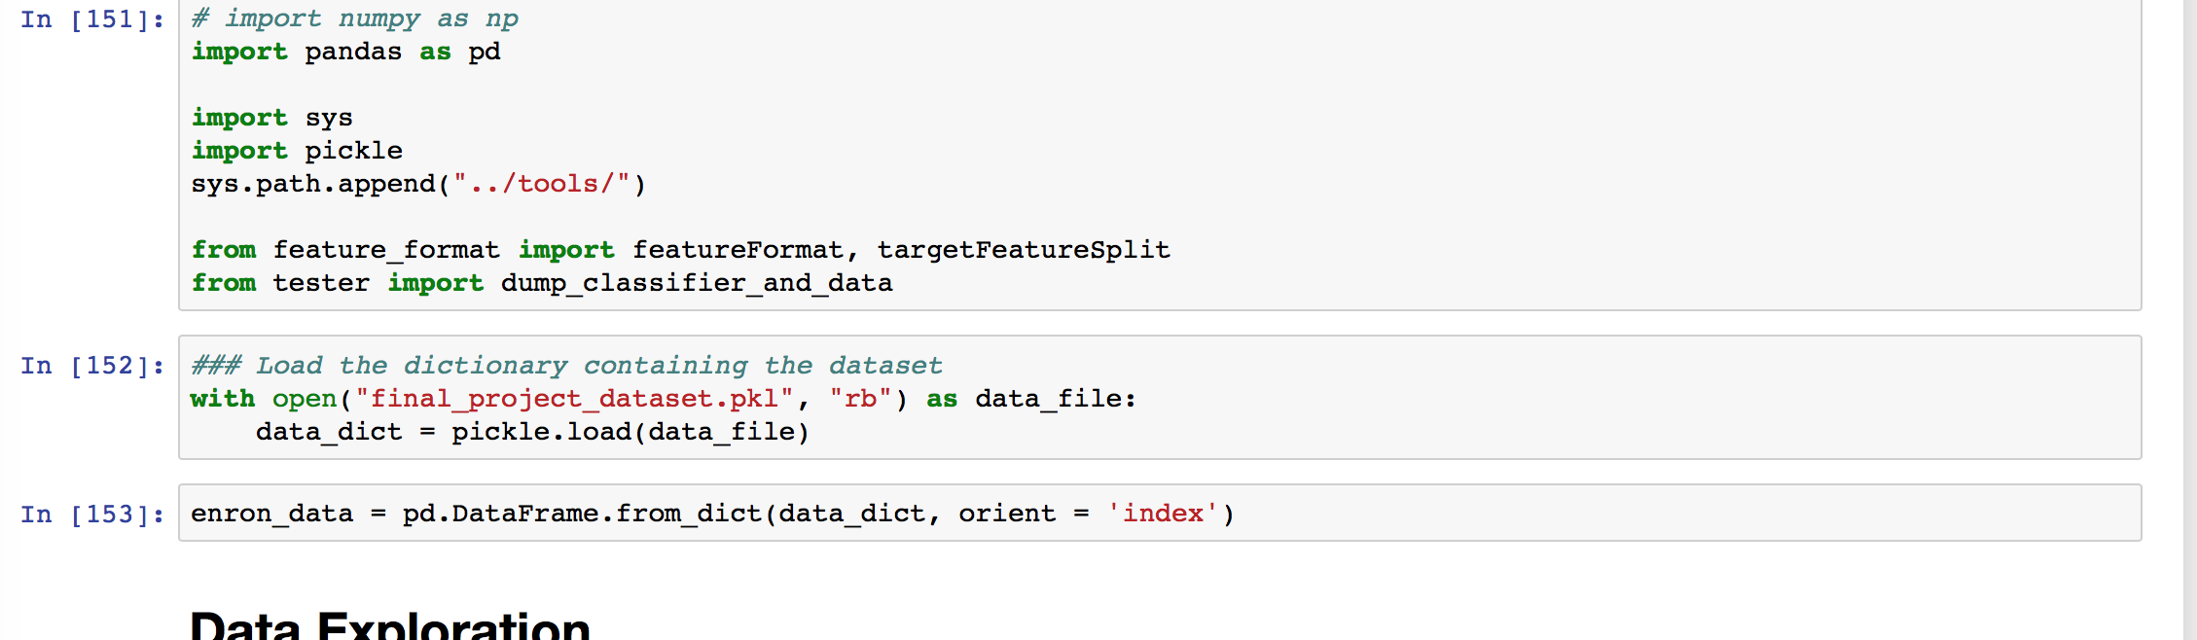
Fig. 1. Lessening the size of the dataset using “pickle”

Using “Panda” to rearrange the dataset index wise.
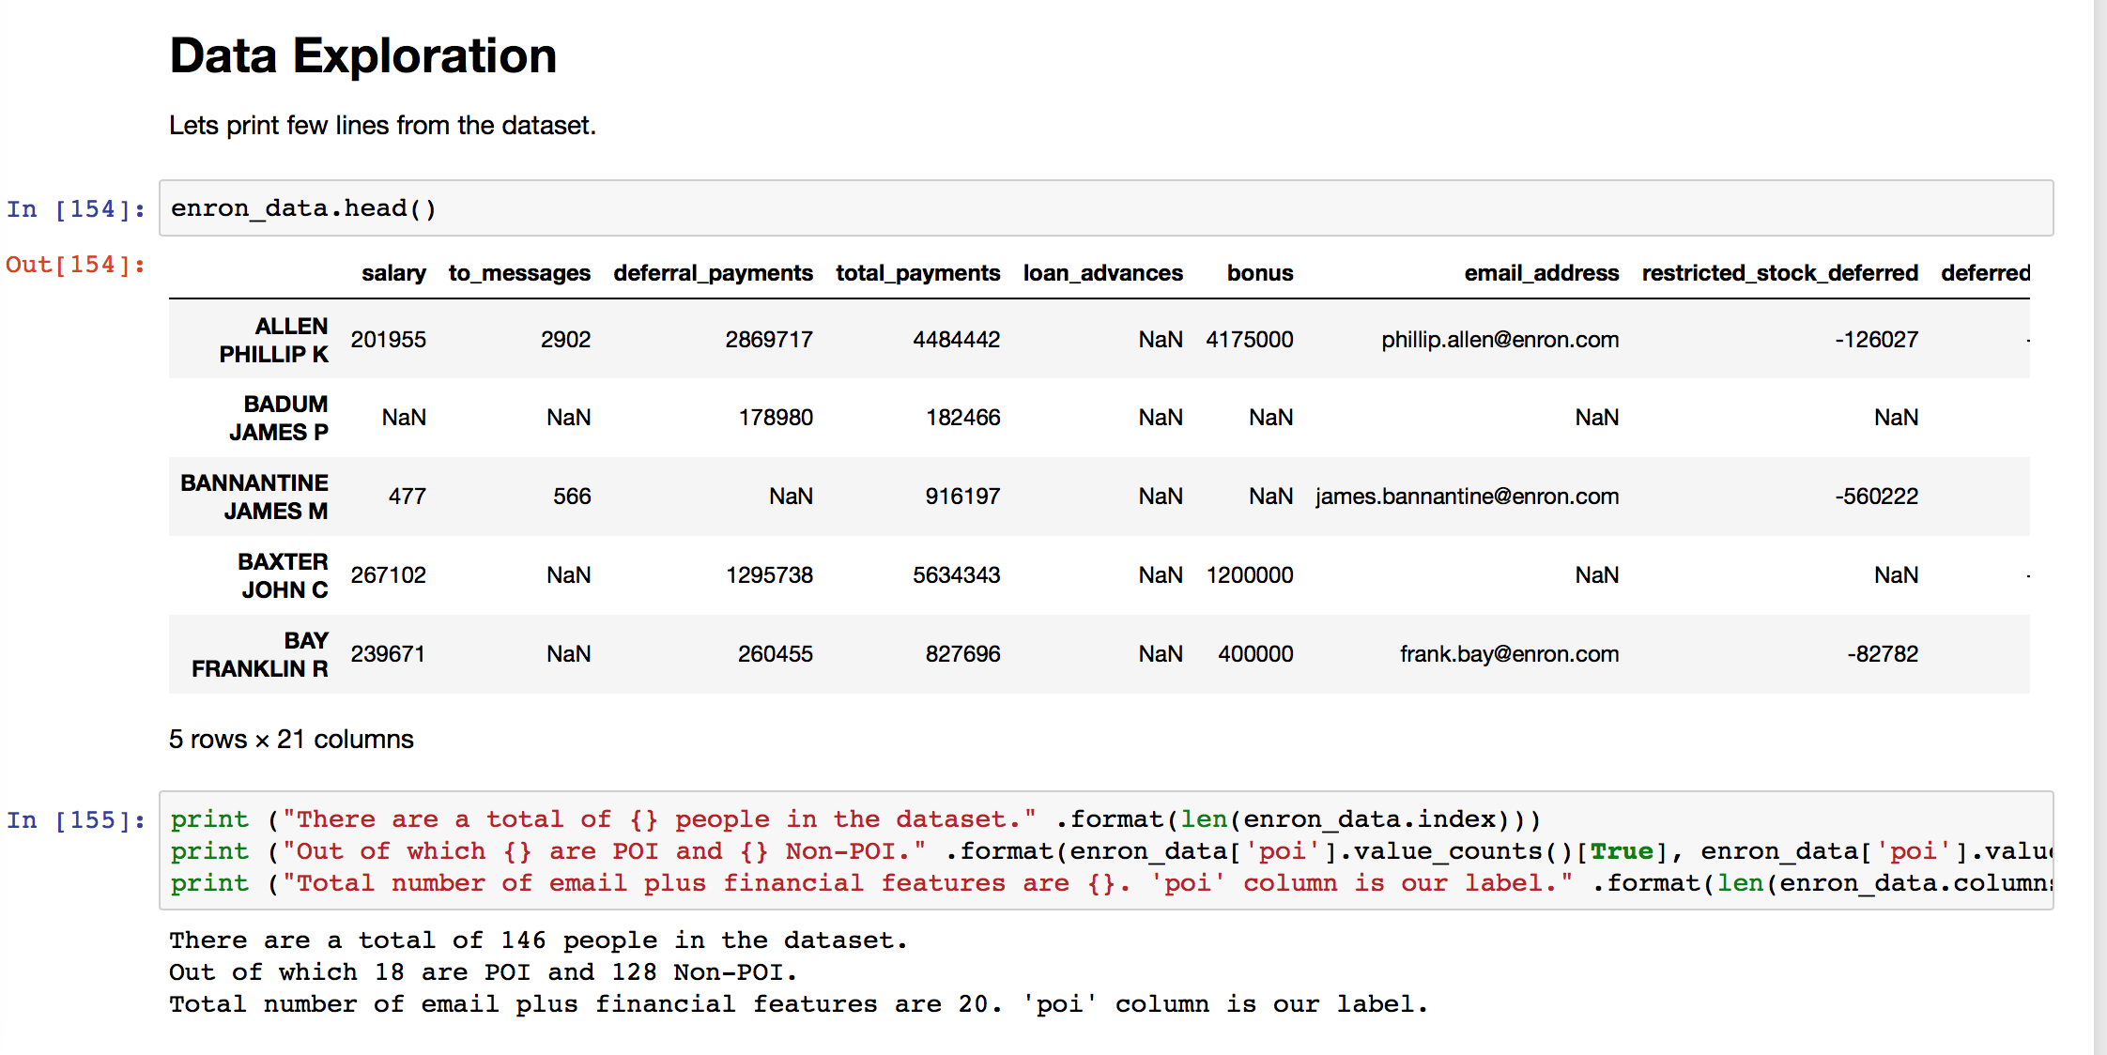
Fig. 2. Making the index.
Using transponse () to rearrange the data and fit into shorter screen.
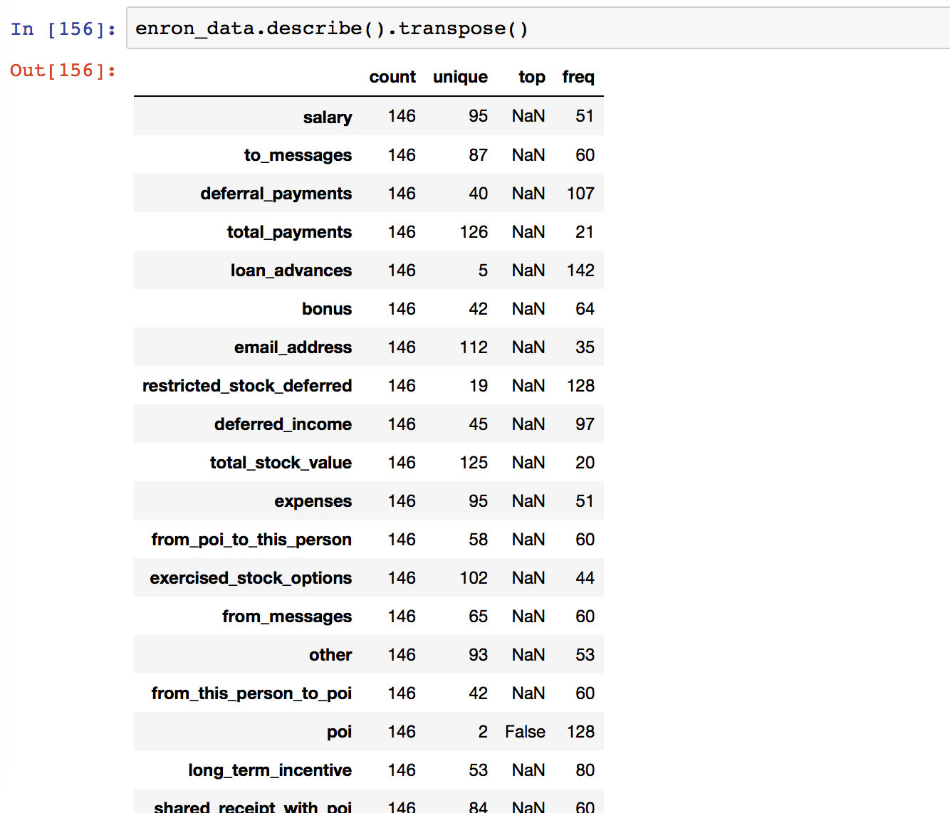

Fig. 3. Transponsing the index

“Plotly” used to plot the graph: 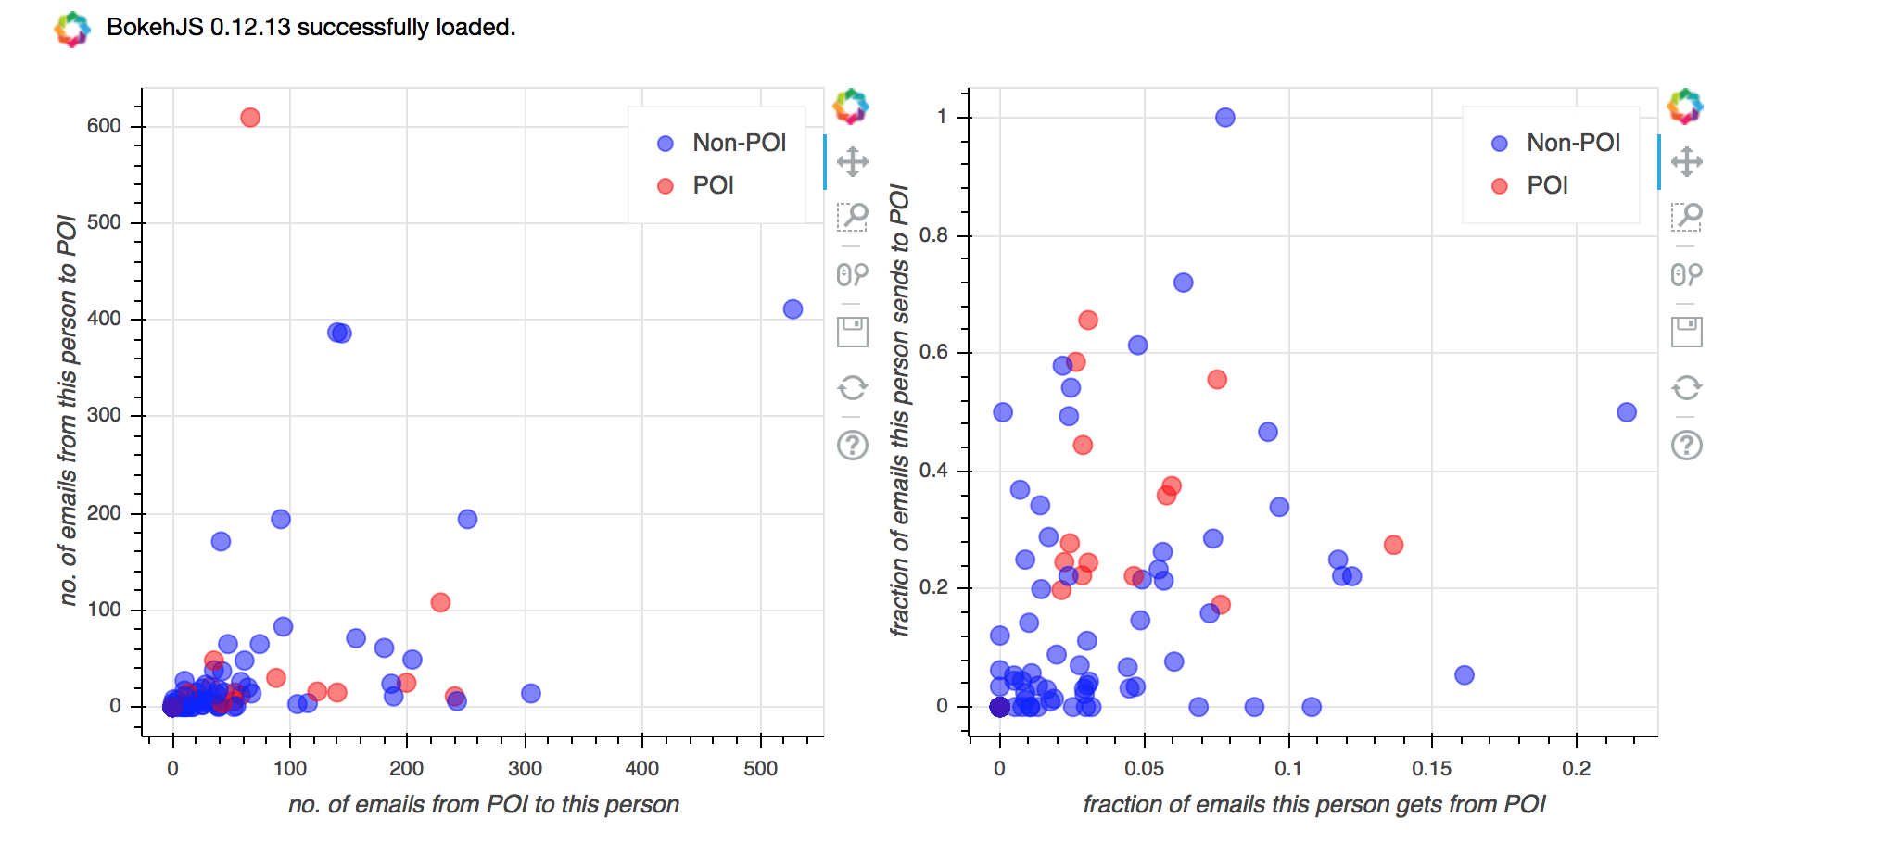
Fig.4.: Graph showing POI and NON-POI vs. the email they are sending.

Feature Engineering
Feature engineering involves using human intuition to hypothesis what feature might contain pattern that can be exploited using machine learning, coding up new feature, visualizing and repeating same process again. Our hypothesis is: “POI’s sent email to each other at a rate higher that NON-POI’s. So we coded up two new features fractions of this person gets from poi’s (fraction_from_poi) and fraction of emails this person.

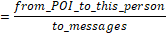

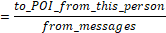

When we visualize these new features, we can see that these new features provide discriminating power between POI and Non-POI. There is good amount of feature space in the lower part of plot (on right) below 0.2 where there are no POIs.

Feature Scaling
We have used decision tree as our final algorithm. Algorithms like decision tree and linear regression don’t require feature scaling, whereas Support Vector Machines (SVM) and k-means clustering does.SVM and k-means clustering calculate Euclidean distance between points. If one of the features has a large range, the distance will be governed by this particular feature. These classifiers are affine transformation variant. In case of linear regression, there is a coefficient with each feature ("Enron Report," n.d.) .
If a feature has large range that does not affect the label, regression algorithm will make the corresponding coefficients small. Even in this case, we don’t have to worry about one dimension, when we are doing something with the other. Hence classifiers are affine transformation invariant.
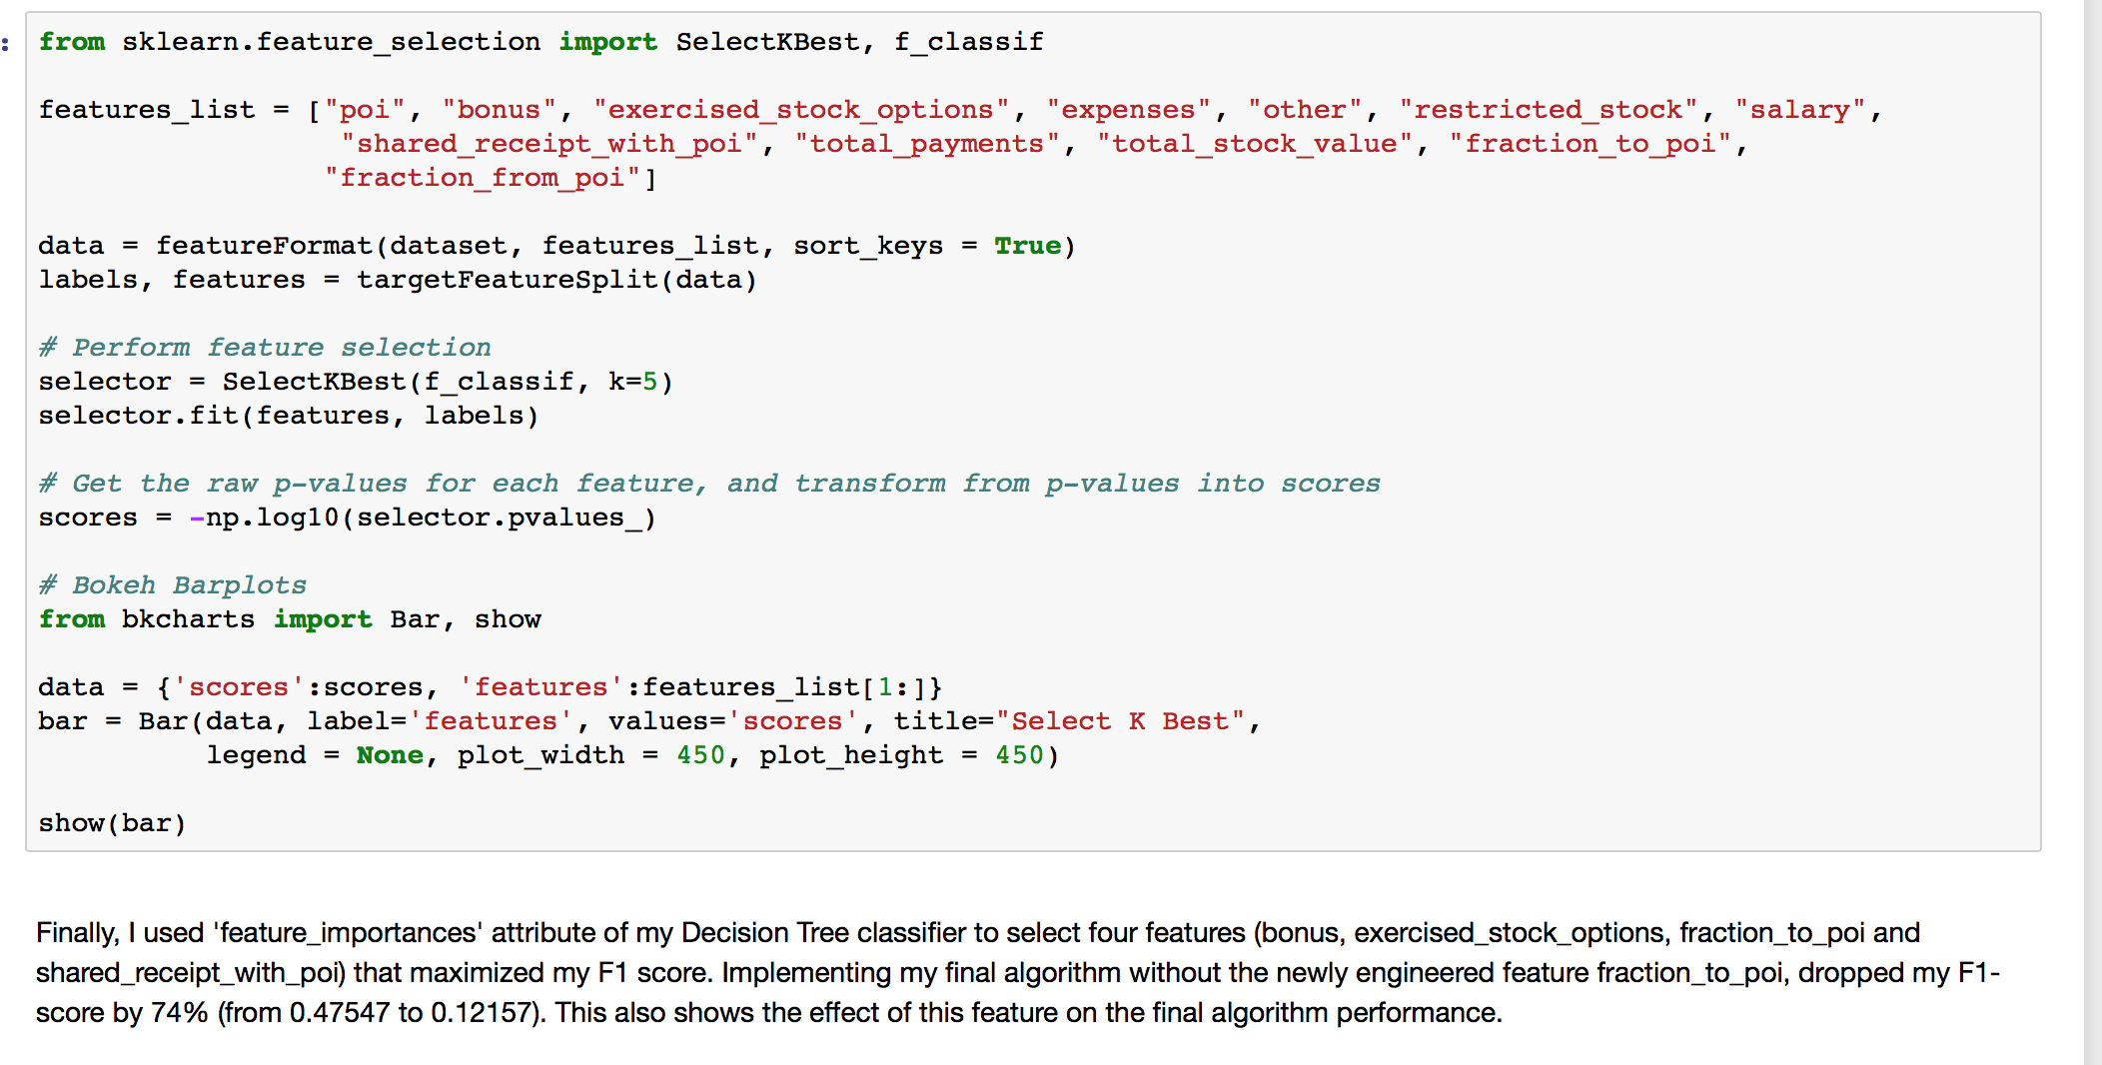 Fig.5. KNN algorithm code .

Result
Validate and Evaluate: We used a variation of k-fold cross validation called StratifiedShuffleSplit. This will make randomly chosen training and test sets multiple times and average the results over all the tests. Data us first shuffled and then split into a pair of training and test sets. Stratification ensures training and test splits have class distribution (POI:NON-POI) that represents the overall data. Stratification is well suited in our case because of class imbalance (18POI vs. 128 Non-POI).

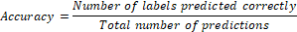

However, accuracy is not ideal for skewed classes. In our case, number of POI are small compared to non-POI. We can have high accuracy by classifying much non-POI correctly and still not have a POI classified correctly. For imbalanced classes like what we have, Precision and Recall are common measures of model performance.

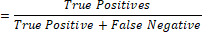

F1 score conveys a balance between precision and recall. It is the harmonic mean of precision and recall.

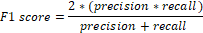

A good F1 score means both the false positives and false negatives are low, and we can identify our POI reliably and accurately. If the classifier flags a POI then the person is almost certainly a POI, and if the classifier does not flag someone, then they are almost certainly not a POI.

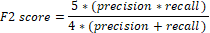

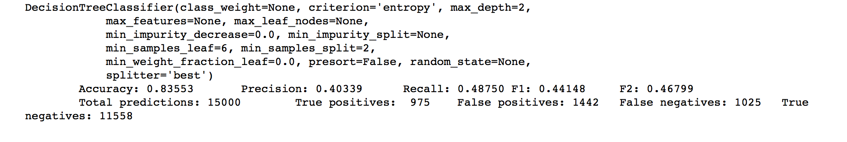Fig.6: The final result showing accuracy :0.083553 Precision: 0.40339 Recall: 0.46799 ; Total predictions :13000 True positives :975 False positives: 1442 False negatives;1005 true negatives:1158

Motivation
The motivation comes from the Enron Scandal in 2001. Enron shareholders filed a $40 billion lawsuit after the company's stock price, which achieved a high of US$90.75 per share in mid-2000 but In 2001 Enron's $63.4 billion in assets made it the largest corporate bankruptcy in U.S. history until WorldCom’s bankruptcy the next year.

Future Work
In future we plan to extend this algorithm and compare with the results of the other algorithm, so that we can increase the accuracy of the project. Also we will work on the interface so that the project becomes more precise.

Conclusion
The goal of this project is to choose a fraud emails and we followed the combination of features of former Enron employees. We choose an appropriate machine learning algorithm to predict whether that person is considered a person of interest (POI) or not. This is considered a Supervised Classification problem as we are trying to predict the discrete outcome, which is binary (2 options only), and we are actually given a data set that contains the right “answers” (whether the person is actually a POI or not). Our goal was be to get the most accurate predictions when we apply our algorithm to test this model. In our case we get the best accuracy of 0.83962

Acknowledgement
We are highly thankful to our honorable faculties Dr.Iftekharul Mobin and Dr. Mohammad Zavid Parvez for their active guidance throughout the completion of this project. We again want to extend our appreciation to them for playing a vital role to inspire us behind the certain.

Reference

- S.Diego , “The Foundation for Enterprise Development Retirement Security and Employee Ownership” , Canada,Policy Reform After Enron , February 15, 2002
- S.A Shabbir , Kannadasan R , “An Effective Fraud Detection System Using Mining Technique” , “International Journal of Scientific and Research Publications,” Volume 3, Issue 5, May 2013 1 ISSN 2250-3153
- . J. Bolton and D. J. Hand. , “Unsupervised profiling methods for fraud detection.” In conference of Credit Scoring and Credit Control VII Edinburgh UK Sept 5-7 2001.

- A. Yasin , A. Abuhasan ,” An intelligent classification model for phishing email detection”, International Journal of Network Security & Its Applications (IJNSA) Vol.8, No.4, July 2016.
- S.N.John,C.Anele,O.Okkokipuije Kennedy,F.Olajide, “Real time Fraud detection in Banking Sector Using Data Mining /Algorithm” , Institues of Electrical and Electronic Engineers (IEEE), 2016
- H.. K. Anupam. J. S. Kumar. K. Y. Yesha "Data Mining: Next Generation Challenges and Future Directions" 2005.

